**Front-End UI/UX Mini Project**

**Project Submission Template**

**1. Title Page**

* **Project Title**: *E-Commerce Product Page*
* **Submitted By**:

|  |  |  |
| --- | --- | --- |
| **FULL NAME** | **ROLL NUMBERS** | **COLLEGE EMAIL ID** |
| Aleena Tomy | 2460318 | aleena.tomy@btech.christuniversity.in |
| Arnima Guha | 2460337 | arnima.guha@btech.christuniversity.in |
| Rosepriya Franci George | 2460437 | rosepriya.franci@btech.christuniversity.in |

* **Course**: *UI and UX Developer*
* **Instructor Name**: *Narendrakumar Gopineedi*
* **Institution**: *Christ University*
* **Date of Submission**: *26/09/2025*

**2. Abstract**

This project presents a modern e-commerce product page designed to showcase retail products effectively while maximizing conversion potential. Built using HTML5, CSS3, JavaScript, Bootstrap, and jQuery, the page features a responsive design, a dynamic image gallery, comprehensive product descriptions, interactive reviews, and a seamless add-to-cart experience. Emphasis is placed on visual hierarchy, usability, and mobile compatibility, reflecting strong front-end UI/UX development skills.

**3. Objectives**

* To design and develop an engaging e-commerce product page capable of driving user conversions.
* To display high-quality product images and detailed descriptions for improved user assessment.
* To showcase customer reviews and ratings for trust building.
* To implement a scalable, responsive layout with Bootstrap for device compatibility.
* To offer an intuitive cart interaction and update mechanism using JavaScript and jQuery.

**4. Scope of the Project**

* Interactive Product Display: Gallery with multiple product images and zoom feature.
* Product Information: Comprehensive descriptions including features, price, and specifications.
* Customer Reviews: Showcasing user ratings with star icons and brief review texts.
* Responsive Layout: Optimized display across desktops, tablets, and mobile phones.
* Add-to-Cart Functionality: Real-time product addition and cart feedback.
* Mobile Optimization: Usable touch targets and adaptive content sizing.

**5. Tools & Technologies Used**

|  |  |
| --- | --- |
| *Tool/Technology* | *Purpose* |
| *HTML5* | *Markup and structure* |
| *CSS3, Bootstrap* | *Styling, responsiveness, grid system* |
| *JavaScript* | *Dynamic UI logic, DOM manipulation* |
| *jQuery* | *Simplified scripting and event handling* |
| *VS Code* | *Source code editing* |

**6. HTML & CSS Structure Overview**

* The HTML uses semantic structure: header for product title, main for gallery, info, reviews, and cart button sections.
* Bootstrap grid and utility classes manage layout for easier mobile-first development.
* Custom CSS complements Bootstrap for refined galleries and interactive hover effects.
* jQuery handles gallery switching and add-to-cart notifications, ensuring smooth interaction.

**8. Key Features**

|  |  |
| --- | --- |
| *Feature* | *Description* |
| *Responsive Design* | *All layouts use Bootstrap’s grid and utilities for seamless adaptation between devices.* |
| *Product Image Gallery* | |  | | --- | | *Thumbnail carousel lets users view product from different angles, using modal for zoomed view.* |  |  | | --- | |  | |
| *Detailed Description* | *Comprehensive product info and pricing in an easy-to-read format.* |
| *Customer Reviews* | |  | | --- | |  |  |  | | --- | | *Visible review section with star ratings and short customer testimonials.* | |
| *Add-to-Cart Button* | |  | | --- | | *Prominent button with dynamic feedback; adds item to session cart using JavaScript.* |  |  | | --- | |  | |

**9. Challenges Faced & Solutions**

|  |  |
| --- | --- |
| *Challenge* | *Solution* |
| *Responsive gallery layout* | |  |  |  | | --- | --- | --- | | |  | | --- | | *Used Bootstrap’s flexible grid and media queries for consistent appearance on all screens.* |  |  | | --- | |  | |  |  | | --- | |  | |
| |  | | --- | | ***Making reviews interactive*** |  |  | | --- | |  | | |  |  |  | | --- | --- | --- | | |  |  | | --- | --- | | *Rendered reviews with dynamic star ratings using jQuery logic for visual feedback.* |  | |  |  | | --- | |  | |
| *Ensuring fast cart updates* | |  | | --- | |  |  |  | | --- | | *Leveraged AJAX with jQuery to update cart asynchronously for a seamless experience.* | |
| *Usable on small displays* | *Simplified component stacking and enlarged touch elements for better mobile usability.* |

**10. Outcome**

* A visually appealing, responsive product page demonstrated across mobile, tablet, and desktop screens.
* Improved customer decision-making via detailed information and trusted reviews.
* Quick, interactive add-to-cart workflow, resulting in improved user satisfaction and conversion.
* Proficiency exhibited in HTML5, Bootstrap, CSS, JavaScript, and jQuery for e-commerce UI/UX.

**11. Future Enhancements**

* Integrate product video demonstrations and 360-degree viewers.
* Implement advanced filtering based on product attributes.
* Enable product variant selection (e.g., colors, sizes) dynamically.
* Add wish-list and user authentication for saved preferences.
* Integrate real-time inventory and backend order management.

**12. Sample Code**

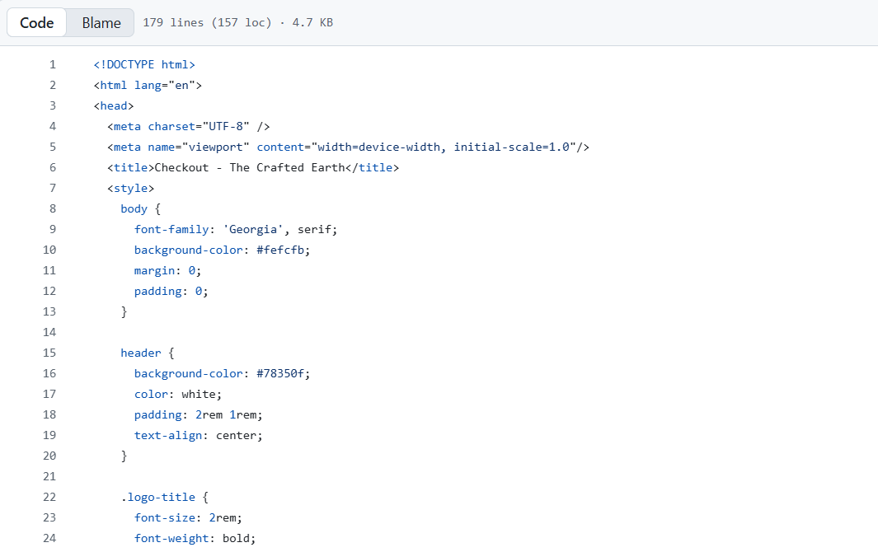

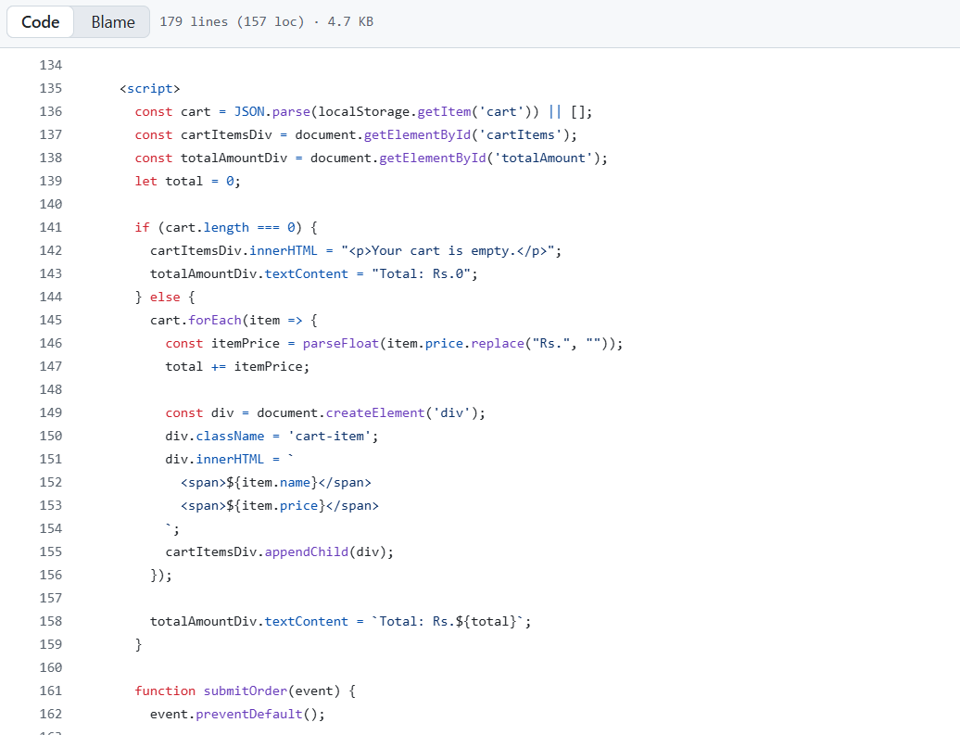

**13. Screenshots of Final Output**

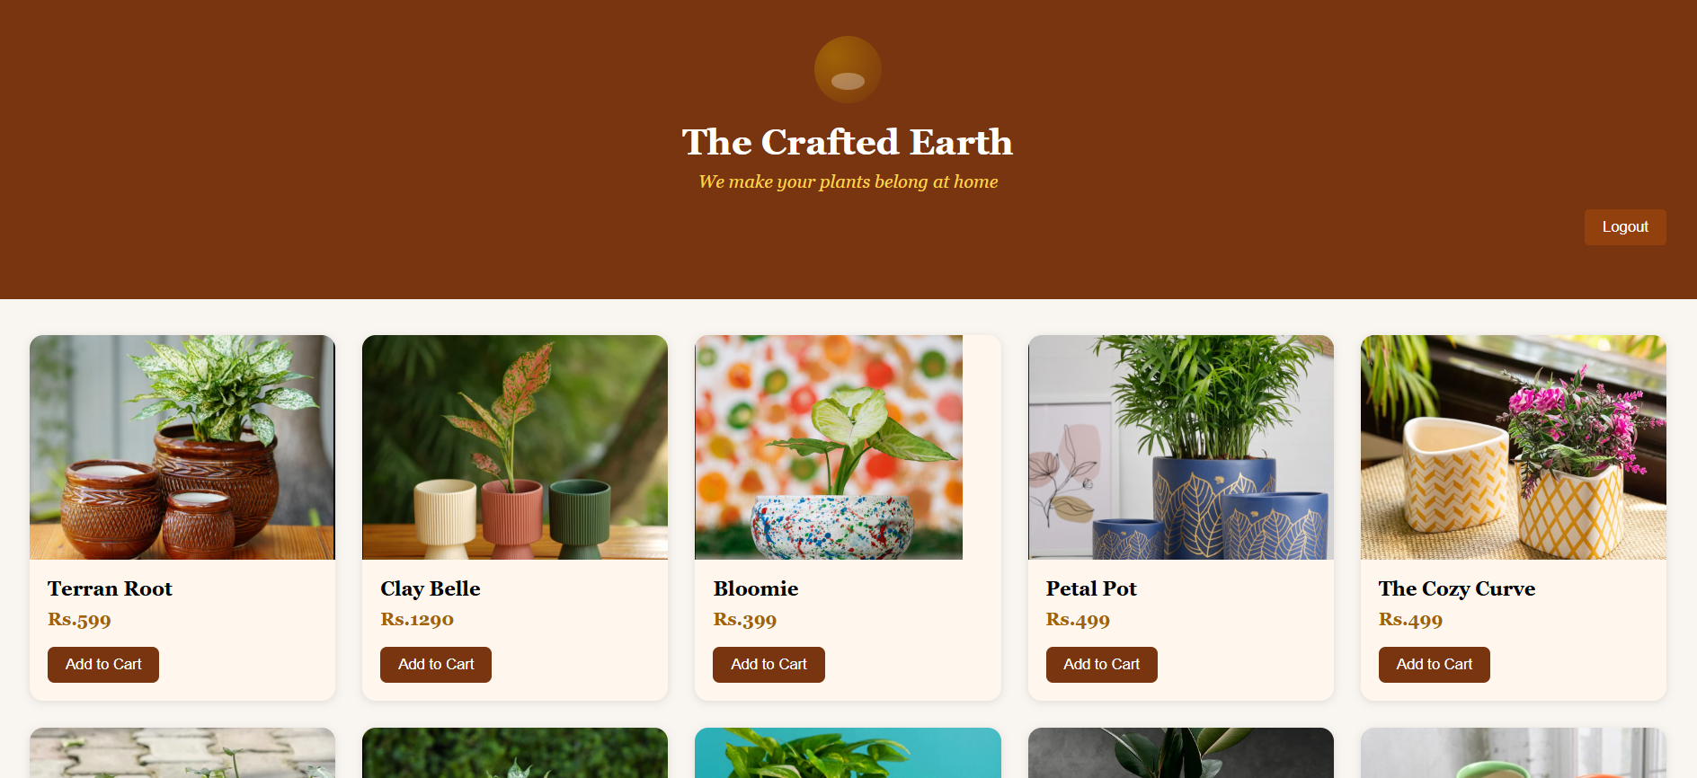

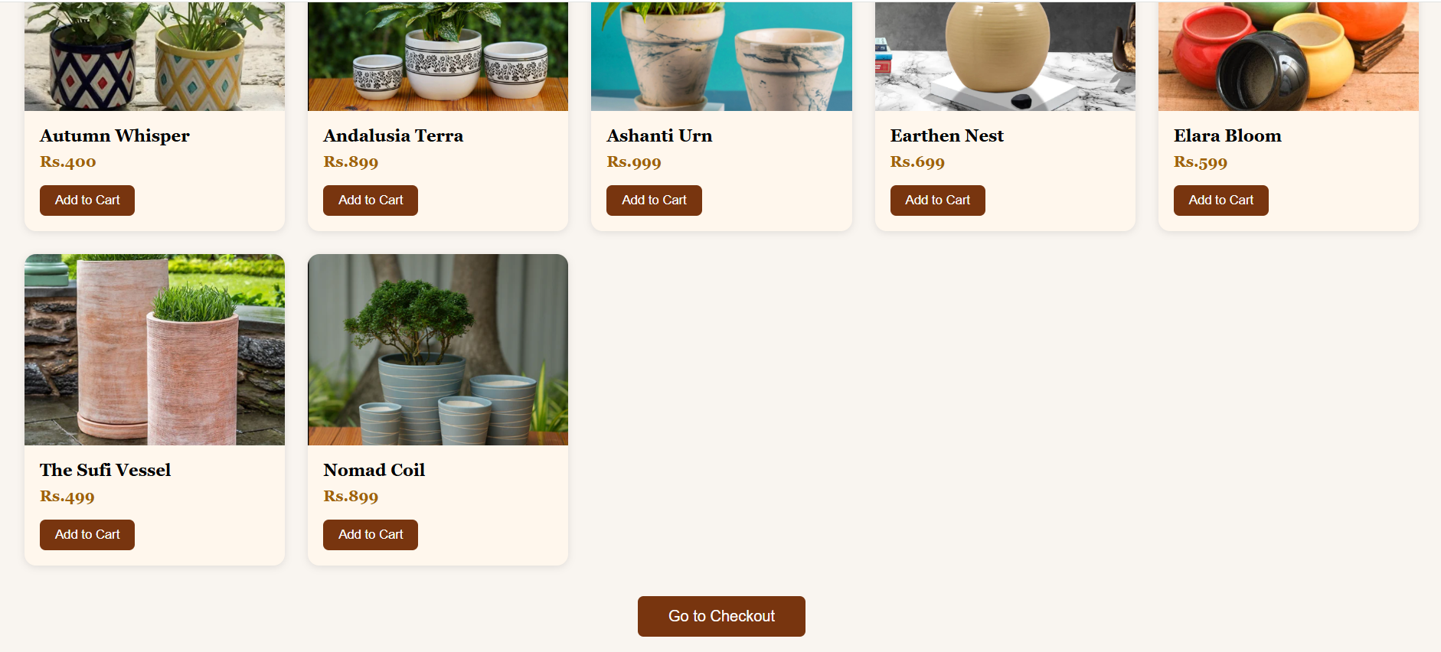

**14. Conclusion**

The E-commerce Product Page project successfully delivers a conversion-optimized, interactive shopping interface that combines essential front-end technologies with effective UI/UX principles. It offers users a visually appealing and user-friendly experience through detailed product images, comprehensive descriptions, authentic customer reviews, and a seamless add-to-cart function, all wrapped in a responsive Bootstrap-based layout. This project not only meets the current standards of online retail by providing clarity, trustworthiness, and eases of use but also lays a strong foundation for scalability and future enhancements such as product customization, video integration, and personalized recommendations. Overall, it demonstrates a holistic approach to designing ecommerce experiences that prioritize both business goals and user satisfaction, equipping learners with valuable skills applicable to real-world digital commerce environments.

**15. References**

L&T LMS: <https://learn.lntedutech.com/Landing/MyCourse>